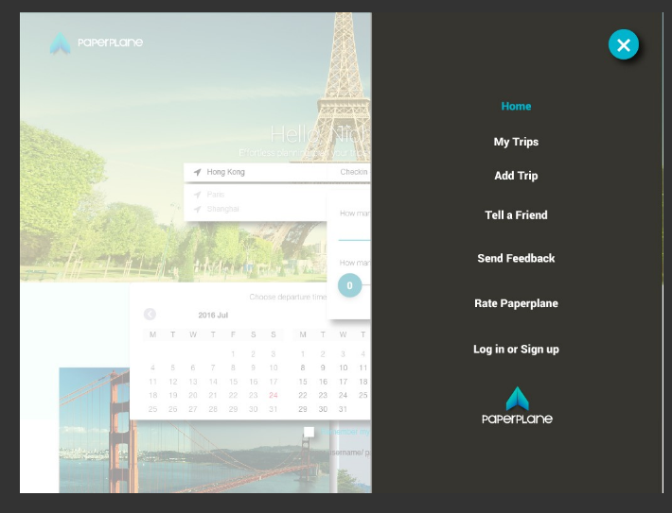

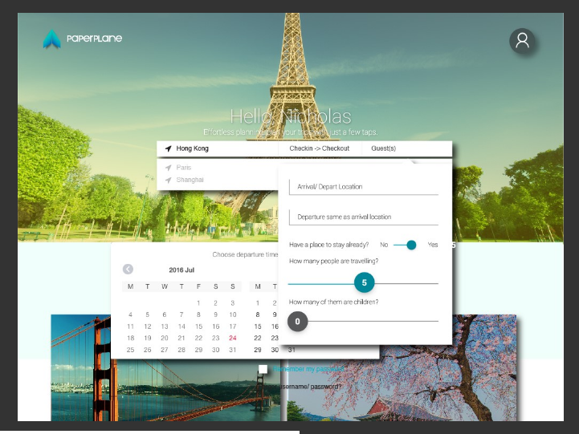

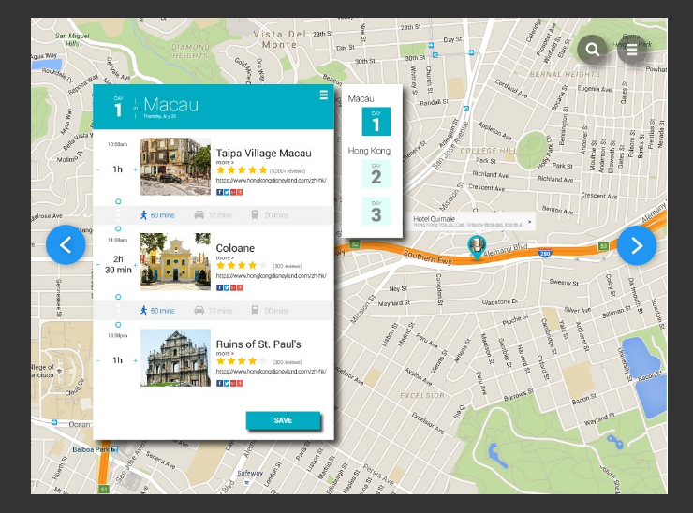

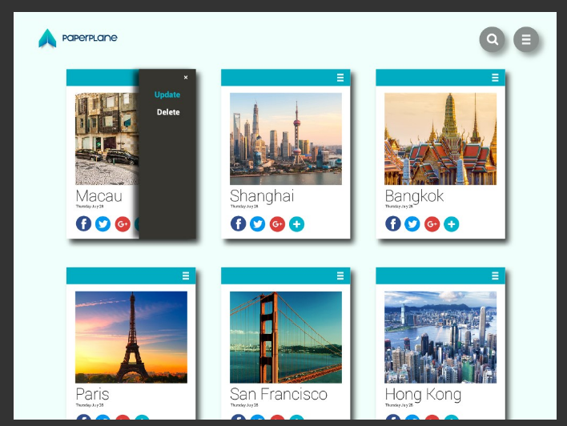

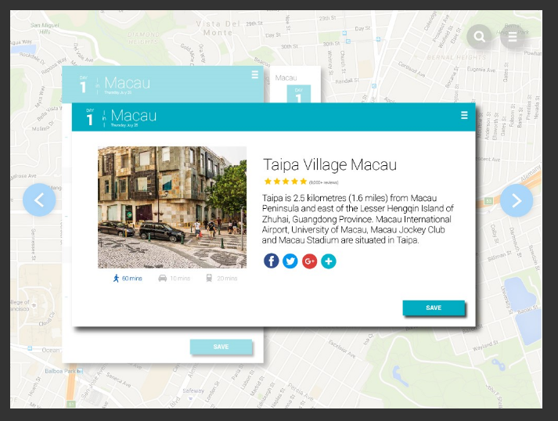

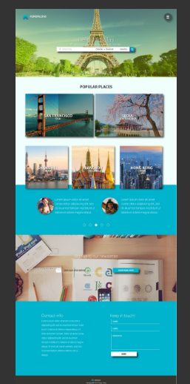

Please find the attached templates for your needs, thanks.

Nicholas

Cofounder & CTO

**Plan your next trip with**[**Paperplane**](https://play.google.com/store/apps/details?id=com.paperplane&referrer=utm_source%3Demail%26utm_medium%3Demail%26utm_campaign%3Dsignature)**on Android**

---- On Wed, 14 Sep 2016 21:46:18 +0800 **Kurucheti,Bhanu Teja <S525040@mail.nwmissouri.edu>**wrote ----

Kurucheti,Bhanu Teja

Reply all|

Wed 9/14, 8:46 AM

Nicholas Ng <nicholas@travelpaperplane.com>;

Gutta,Hima Teja;

+5 more

Sent Items

Hi Nicholas -

Could you please provide a template for the homepage so we could build on that? Thank you.

Teja

**From:** Nicholas Ng <nicholas@travelpaperplane.com>  
**Sent:** Tuesday, September 13, 2016 9:46 PM  
**To:** Pidaparthy,Adarsh Kumar Reddy; Kurucheti,Bhanu Teja; Kattekola,Sai Sumanth; Kandula,Sai Raj Kiran; Madarapu,Sravya; Gutta,Hima Teja; Nallamothu,Vamshinath; Rudra,Saichaitanya; Chilukuri,Harish Kumar; Padaraju,Keerthi; Varkala,Kishore Kumar; Painuly,Krishna Kumar; Akula,Nikhil Kumar; Gajam,Swetha K; Manthena,Suprem Raju; Gaddam,Snigdha; Akkiraju,Prahasith; Rayaprolu,Naga Adithya; Abbu,Srilatha Reddy; Kommineni,Kusumasree; Abdul,Arshad  
**Subject:** Re: Paperplane - Anyone Here?

Hi Team,

To facilitate the communication, please add my Skype: ngheungyu

And feel free to ask me questions there. Cheers.

Nicholas

Cofounder & CTO

**Plan your next trip with**[**Paperplane**](https://play.google.com/store/apps/details?id=com.paperplane&referrer=utm_source%3Demail%26utm_medium%3Demail%26utm_campaign%3Dsignature)**on Android**

---- On Mon, 22 Aug 2016 11:24:55 +0800 **Nicholas Ng <nicholas@travelpaperplane.com>**wrote ----

Hey guys,

Hope you guys enjoyed the summer! Please let me know if you're in MO and ready to kick off the project!

Thanks.

Nicholas

Cofounder & CTO

**Plan your next trip with**[**Paperplane**](https://play.google.com/store/apps/details?id=com.paperplane&referrer=utm_source%3Demail%26utm_medium%3Demail%26utm_campaign%3Dsignature)**on Android**

Paperplane - Anyone Here?

Nicholas Ng <nicholas@travelpaperplane.com>

|

Tue 9/13, 9:46 PM

Hi Team,

To facilitate the communication, please add my Skype: ngheungyu

And feel free to ask me questions there. Cheers.

Nicholas

Cofounder & CTO

**Plan your next trip with**[**Paperplane**](https://play.google.com/store/apps/details?id=com.paperplane&referrer=utm_source%3Demail%26utm_medium%3Demail%26utm_campaign%3Dsignature)**on Android**

---- On Mon, 22 Aug 2016 11:24:55 +0800 **Nicholas Ng <nicholas@travelpaperplane.com>**wrote ----

Nicholas Ng <nicholas@travelpaperplane.com>

Reply all|

Sun 8/21, 10:25 PM

Pidaparthy,Adarsh Kumar Reddy;

Kurucheti,Bhanu Teja;

+20 more

Inbox

Action Items

Hey guys,

Hope you guys enjoyed the summer! Please let me know if you're in MO and ready to kick off the project!

Thanks.

Nicholas

Cofounder & CTO

**Plan your next trip with**[**Paperplane**](https://play.google.com/store/apps/details?id=com.paperplane&referrer=utm_source%3Demail%26utm_medium%3Demail%26utm_campaign%3Dsignature)**on Android**

Hotel information in JSON

Nicholas Ng <nicholas@travelpaperplane.com>

|

Today, 8:24 PM

Please ignore the hotel data.

Kurucheti,Bhanu Teja

Reply all|

Today, 1:22 PM

nicholas@travelpaperplane.com;

Nallamothu,Vamshinath;

+7 more

Sent Items

Nicholas,

We are from Paperplane Website team. We have observed that hotel information has been removed from the mobile app but there is hotel information in JSON provided by you. Please confirm if we should we include it or not? Thank you.

**Bhanu Teja Kurucheti**

Northwest Missouri State University

660.528.5827 cell | [S525040@nwmissouri.edu](mailto:mhorn@nwmissouri.edu) |

Kurucheti,Bhanu Teja

Reply all|

Tue 11/8, 4:12 PM

Nicholas Ng <nicholas@travelpaperplane.com>;

+8 more

|  |  |
| --- | --- |
| [itinerary_data.json210 KB](https://outlook.office.com/owa/service.svc/s/GetFileAttachment?id=AAMkAGU1MWY2MWU3LTY5MjctNDk3MS04YTcxLWMxYzUwMzRmNmVkMQBGAAAAAABv5CeT2FizR7aXLCdHcLQkBwC4RoPVj1InQJ2NHpUIs9FnAAAAAAEMAAC4RoPVj1InQJ2NHpUIs9FnAAEfH2jqAAABEgAQANn56A%2BoNGRPujXRCynqcPE%3D&X-OWA-CANARY=h9crQNdfb0O6dz6MU9oE4qC4vMXTCdQYYfWeDHsQo16yK4ejKhocODXch3HhNMqOBjvj9GvyYyA.) | [Script for generating maps.txt2 KB](https://outlook.office.com/owa/service.svc/s/GetFileAttachment?id=AAMkAGU1MWY2MWU3LTY5MjctNDk3MS04YTcxLWMxYzUwMzRmNmVkMQBGAAAAAABv5CeT2FizR7aXLCdHcLQkBwC4RoPVj1InQJ2NHpUIs9FnAAAAAAEMAAC4RoPVj1InQJ2NHpUIs9FnAAEfH2jqAAABEgAQAK1y%2BEAMZ01NuTEwlcmXVEk%3D&X-OWA-CANARY=h9crQNdfb0O6dz6MU9oE4qC4vMXTCdQYYfWeDHsQo16yK4ejKhocODXch3HhNMqOBjvj9GvyYyA.) |

2 attachments (212 KB) Download all

Save all to OneDrive - Northwest Missouri State University

Nicholas,

We are from Paperplane website team. As per your suggestion, we cleaned the JSON file by removing all hotel related data. Please find the attachment for reference.

We were successful in parsing the file but unable to plot the coordinates from the file. If we supply data parsed from the JSON file as waypoints, points are not plotted on the maps. Please find the sample code for reference and suggest.

Teja

Nicholas Ng <nicholas@travelpaperplane.com>

|

Today, 6:31 AM

So as discussed during demo,

please use google’s tools to decode the “polyline” data, so you can plot the gps lines on google maps

cheers.